

**MOUNT CARMEL COLLEGE** **BANGALORE**

**TOPIC:**

**ELECTRIC VEHICLES**

**SUBJECT:**

**INDIAN ECONOMICS**

**Submitted To:**

Dr Rupa Sarkar & Dr Kaumudi Mishra

Department of Economics

Mount Carmel College

**Submitted by:**

VANSHIKHA AGARWAL- MS193652  
SHARANYA NAIK- MS193656  
NEHA ANN CHERIAN- MS193618  
DHRITI R PUTHRAN- MS193662  
ADITI SWAMINATHAN- MS193657

Vth BSc. EMS

**MOUNT CARMEL COLLEGE AUTONOMOUS**

**CERTIFICATE**

***This is to certify that M/S*** VANSHIKHA AGARWAL- MS193652, SHARANYA NAIK- MS193656, NEHA ANN CHERIAN- MS193618, DHRITI R PUTHRAN- MS193662, ADITI SWAMINATHAN- MS193657  
***have completed the assignment topic under the guidance of Dr Rupa Sarkar & Dr Kaumudi Mishra in Dept. of Economics.***

***Signature of the Teacher Educator Signature of Head of the Department***

**ABSTRACT**

This paper focuses on the sales of electric vehicles in India and the three main platforms that are affected by it which include the fuel prices (petrol and diesel), battery costs (battery pack and cell prices) and CO2 emission in the country.   
While India transitions into the era of an electric vehicle driven economy, there are some limitations and merits that are considered in the following study.

We have used EXCEL to obtain a regression model to predict the futuristic aspects of electric vehicles and how it will change the dimensions of automobile industry in India.

Lastly, we have also mentioned various schemes proposed by the government to accelarate the sales of EVs.

**INTRODUCTION**

Transport infrastructure plays a catalytic and major role in the economic growth and development of any region. There has been a linear growth in the number of vehicles and this leads to large amounts of fuel consumption and thus GHG emissions.

Air pollution in India is one of the serious health issues and is one of the greatest threats in the global context. India, being a country comprising of world second largest population of almost a 130 million (equivalent to 17.7% of world’s population), is facing serious air pollution issues since a decade which is increasing at an alarming rate.

India is ranked 3rd for the most air polluted countries. The main reasons for this exponential increase in the pollution levels is poor fuel quality, usage old vehicles, inadequate maintenance, congested traffic etc. Reason behind large share of vehicular pollution is India’s gigantic automotive industry. The major pollutants emitted from the automobiles are hydrocarbons, nitrogen dioxide, lead, carbon monoxide, sulfur dioxide, and particulate matter.

This air pollution cost adds on to the welfare costs. Air pollution costs Indian businesses about USD **95 billion (7 lakh crores)** every fiscal year which is around **3% of India’s total GDP.** The government's aim has been to mitigate the rising concern of increasing emissions of GHG which results in poor air quality and the remedial measures taken to reduce emissions is by introducing EV’s and HEV’s (hybrid EVs). he population of electric vehicles in India is increasing at the rate of 37.5%.

**­­**

**ADVANTAGES OF EVs**

In order to reduce air pollution and make the world sustainable for the future generations, we need to switch over to an alternate source of transportation from ICE convention vehicles to EVs as they are:

* Environment Friendly:

Compared to ICE vehicles EVs do not produce smoke which does not cause air pollution. EVs don’t even have an exhaust system, which means they have zero emissions. Since they are gas-powered vehicles, they are large contributors to greenhouse-gas making. The switch to EVs can help in making the planet healthy.

* Cheaper than gasoline:

Per kilometre cost of EVs is cheaper compared to ICE vehicles.  The fact cannot be denied that many EVs run at one-third of the cost, given electricity is significantly less expensive than gasoline. And since consumer charge there EVs in garage most of the time, installing solar panels at home can save even more money.

* Low Maintenance:

Due to the absence of internal combustion engine in EVs its maintenance isn’t a burden.

**BRIEF LITERATURE REVIEW**

**ELECTRIC MOBILITY IN INDIA:**

A total of **5,30,560 EVs** (including electric two-wheelers [e-2W], electric three-wheelers [e-3W], electric rickshaws [e-rickshaws], electric cars [e-cars], and electric buses [e-buses]) were sold in India (CEEW - Centre for Energy Finance 2020). This is lower from the **National Electric Mobility Mission Plan (NEMMP)** 2020 target of 6-7 million EV and hybrid sales by 2020. However, there is a steady uptick in the sales of EVs since 2017.

A number of high-voltage electric cars were launched towards the end of 2019 and many more models showcased at the Auto-Expo 2020 were being prepared to be launched, including Tata Altroz EV, Mahindra eKUV100, and MG Marvel X.

The COVID-19 pandemic has disrupted the global supply chains for EV components, mainly power electronics, battery, and the minerals that are used in these components. The supply chain disruption has cast its shadow over the entire auto-industry, not just the EV sector. Although the EV industry in India stands uncertain, experts are divided on how the EV sector will eventually emerge out of the present situation: some have forecast stagnation while others see a possibility of the Indian EV sector becoming a strong contender in the global electric mobility manufacturing space.

**INDIA’S POLICY ON ELECTRIC VEHICLES:**

The Government of India has given a call for ‘**Only Electric Vehicles**’ on Road by 2030. India’s primary focus is to contain the increasing pollution and reduce carbon footprint.

In 2012,  National Electric  Mobility  Mission  Plan (NEMMP)  2020  was  established,  under  which  an  incentive scheme,  Faster  Adoption  and  Manufacturing  of  Hybrid  and Electric Vehicles (FAME), was launched in  2015  to reduce the cost of hybrid and electric vehicles and to encourage their penetration  in  the  market.

 According to the **International Energy Agency (IEA)** only 30% of the new vehicle sales in India will be electric by 2030 which is significantly different from theGovernment of India’s target of only selling electric vehicles by 2030.The report notes that the EV penetration in India will mainly be led by electric two-wheelers and three-wheelers, which will reach a cumulative sales share of almost 50%. It also highlighted that the rate of electrification of buses and light-duty vehicles will be lower, expected to be below 15% of the total sale share by 2030.

The Indian govt (on Sep 15 2021) approved Rs 25,938 crore PLI scheme for the automobile and auto ancillary sectors to promote domestic manufacturing of green vehicles and enable India to become a part of the global supply chain.

Petrol and diesel vehicles haven’t been included in this scheme. This is because the focus is to promote the transition to clean automotive technologies which are expected to gain volumes in the coming years.

Scheme is expected to generate

-investments of over Rs. 42500 crores in 5 years

-incremental production of over Rs. 2.3lakh crores

-additional employment for over 750,000 people

**REASONS FOR THE SLOW ADOPTION OF EV’S IN INDIA:**

Presently, there are many challenges for the EVs market. The major role to run the Electric Vehicle in India is power generation. Without electricity, we cannot imagine Electric Vehicles running on road.  Therefore, responsibility of distribution network increases to supply the proper electric power without failure.

* High Cost:

Cost of buying EV is quite high when compared to that of  an  ICE  vehicle  i.e.,  the  average cost of electric cars  in India  is  around 13  Lakh (INR),  which  is  much  higher  than the  average  INR  5  Lakh  for  economical  cars  run  on traditional fuel. These are mainly due to the lithium import for battery making and since batteries make up to about 50% cost of the vehicle therefore EVs are costlier. Lithium is a rare metal which has its high reserves in countries like Chile, Australia, and Argentina.

* Lack of charging infrastructure:

The main hindrance behind commercial viability of EVs in India is inadequate charging infrastructure. India only had 650 charging stations in 2018, whereas China had over 456K charging  points  in  the  same  year.  Other reason creating anxiety is  charging  time.  Battery  charger  efficiency according  to  the  present available technologies all  over  the world varies in percentage from low 70s to high 90s.

* Range anxiety:

Range anxiety is one of the most significant roadblocks to EV adoption. EVs  generally  have  shorter  range  which causes charging fear  in  consumers mind. At present longest range EV available is  Tesla’s model S which has  a range of 370  miles  per  charge.  But since Tesla  is  not  entered  the Indian market so Indians do not have reach to this high range vehicle. EVs available in India do not have range more than 500 km per charge. This is deeply associated  to  the  lack  of charging  infrastructure  in  the  country,  and  while conventional vehicles can be re-fueled at petrol stations, such is not the case when it comes to EVs.

* Purchasing price:

One obstacle for the adoption of EV’s could be the initial purchasing price/cost and its battery replacement cost. Inspite of government tax-breaks and incentives, EV’s initial purchase price is about 30% higher than the conventional vehicles. However during the vehicle’s life cycle, the difference in purchase price is often offset by savings on fuel and maintenance.

* Low operating range-

The average range for the electric 2 wheelers currently available in the market is around 84km per charge and for electric cars is 150-200 km per charge.

**IMPACT OF TRANSITIONING TO EV’S ON ECONOMY:**

Among the many measures taken to revive the economy in the aftermath of COVID-19, electric mobility should be prioritized as a key sector for India’s economic recovery and sustainable growth. In an EV30 scenario, the domestic value-add generated in manufacturing, reduction in oil import bill, and environmental and health benefits far outweigh the loss in value addition from the petroleum and automotive sectors.

When comparing direct jobs, there are more jobs lost than created in the transition. However, assessment of job creation only considers direct manufacturing jobs associated with EV powertrain, batteries, and charging infrastructure and jobs in the electricity sector. Direct jobs from activities such as installation and operations, charging infrastructure, battery recycling, telematics, and other service-related jobs and indirect jobs have not been taken into account.

But the EV roadmap for India should identify activities beyond manufacturing within the EV value chain for job creation. If EVs garner 30 per cent of vehicle sales by 2030, the central and state governments are set to lose revenue from petrol and diesel taxes by 15%. When pushing for EV transition, the government’s plans should also include diversification of revenue sources.

1. **Impacts arising from the change in oil consumption:**

 In FY19, the oil consumption from road transport stood at 91 Mtoe. Petroleum imports constituted nearly one-third of India’s total imports in value terms and the country imported 87 per cent of its domestic consumption of crude oil according to provisional estimates (MoPNG 2020). So the government has set a target of reducing oil import by 10% by 2022. Electric mobility and limiting private vehicle ownership hold key to achieving this target.

1. **Reduction the petroleum tax revenue of central and state governments:**

While the intent is to bring down the consumption of petrol and diesel through changes in mode-share and fuel mix, it is to be noted that the petroleum sector is a significant contributor to revenues for the centre and states in the form of taxes and dividend income. The total revenue realized from taxes on petrol and diesel was INR 5,76,000 crore in FY19, with 60 per cent of these revenues going to the centre and the remaining to the states.

Tax on fuel constitutes 15–20 per cent of tax revenue for the majority of the states (RBI 2019). The central government would lose 15–31 per cent of potential petroleum tax revenues in 2030. On the other hand, in a high private vehicle scenario, the central and state governments, respectively, gain a revenue of 4 and 8 per cent in the form of fuel taxes.

1. **Impact on employment:**

In the course of transition to electric mobility, new high-skilled jobs in the manufacturing of batteries, EV powertrain, and charging infrastructure are likely to be created. Additional consumption of electricity will drive job creation in the power sector. Simultaneously, reduced consumption of oil would lead to a reduction in jobs created in the petroleum sector and in internal combustion engine (ICE) vehicle manufacturing. The petroleum value chain (refining, processing, wholesale, and retail) creates the least number of jobs per INR 1 crore of output value-added. If the EV transition at EV30 is reached, it is likely to result in a reduction of 19 per cent of jobs in the petroleum and automotive (ICE vehicle) sectors.

For EV industry to thrive it is essential to train existing workforce for new jobs. As the EV sector scales up, the new jobs created in the EV value chain would require imparting training and skilling to create a workforce that can cater to the needs of EV manufacturing as a prerequisite to meet any anticipated demand for EVs.

**METHODOLOGY**

REGRESSION MODEL FOR SALES (DEPENDENT VARIABLE) AND FUEL (DIESEL AND PETROL SEPARATELY) PRICES (INDEPENDENT VARIABLE)

PETROL AND DIESEL PRICES IN LITRES (Rupees)

SALES ON PER YEAR BASIS, CONSIDERING ONLY 2 AND 4-WHEELER EVs



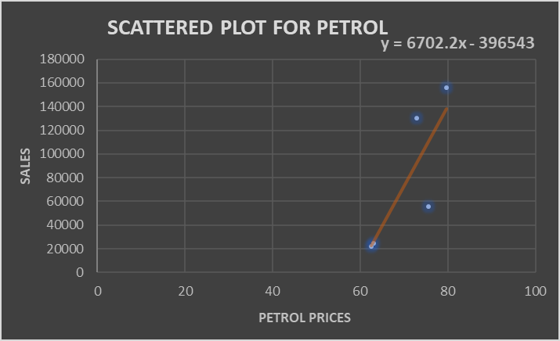

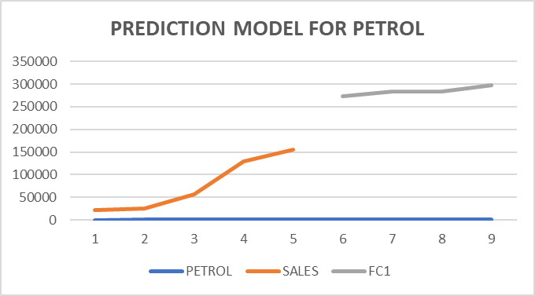

FC= regression model used by the regression equation

Y=a+bx where

|  |  |  |  |  |
| --- | --- | --- | --- | --- |
| SLOPE (b) | 6702.226 |  | INTERCEPT (a) | -396543 |

Analysis- From the above model we can analyse that the slope gives us a positive relation between the electronic vehicle sales and petrol prices. We can also observe that the prediction done for the months of July to October 2021 show a further increase in the sales of EVs with the continuous increasing petrol prices.



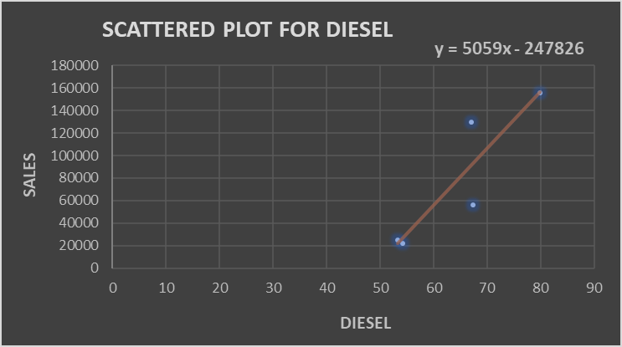

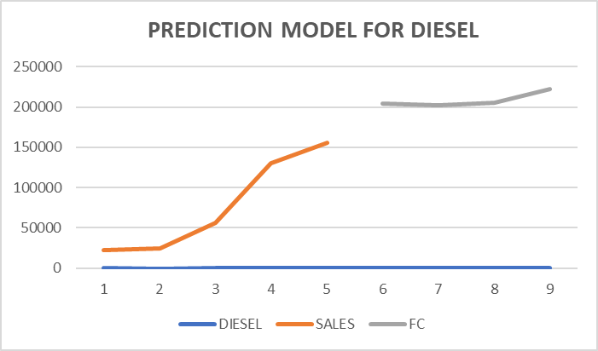

where, to predict the values

FC= FORECAST METHOD USING THE REGRESSION EQUATION

FC formula = a+bx, where a= intercept; b=slope

|  |  |  |  |  |
| --- | --- | --- | --- | --- |
| SLOPE(b) | 5058.969 |  | INTERCEPT(a) | -247826 |

Analysis- The above data shows the positive relationship between the diesel prices and sales of EVs with a prediction model for the year 2021. Sales will shoot up further in EVs with the increasing diesel prices however, the sales will be still lower in comparison to the case of petrol prices and sales of EVs.   
Thus, we can observe that more people using petrol driven cars will soon be switching to EVs since it is more economically beneficial and eco-friendly.

BATTERY PACK PRICE AND CELL PRICE ARE INDEPENDENT VARIABLES IN 100/KILOWATT HOUR IN DOLLARS

What are battery pack?   
A battery pack is a set of any number of (preferably) identical batteries or individual battery cells. The battery pack high voltage system is designed to control power flow to and from the cells and to maintain the power level within the design envelope.



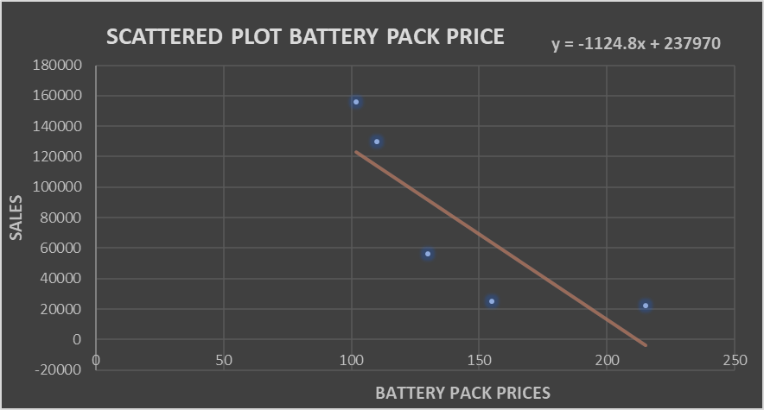

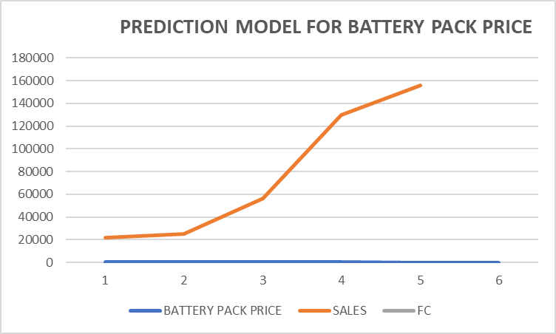

|  |  |  |  |  |
| --- | --- | --- | --- | --- |
| SLOPE (b) | -1124.79 |  | INTERCEPT (a) | 237969.8495 |

Analysis- From the above data we can analyse that there is a negative or an inverse relation between the battery pack prices and sales of EVs. This is so because, these batteries are a raw material for the electric vehicles on which they run. If the battery prices rise, it will lead to increase in cost of production and hence, increase in EV prices which will then result in less demand. Thus, we can observe that in our prediction model which is only done for 2021, the battery prices are same which leads to a slight decrease in the sales of EVs. Thus, only a further decline in the prices will get the sales to rise up.

What are cells in EV?   
The conventional battery pack uses cells to build a module and then assembles modules into a pack. A blade battery pack builds on wide and short cells and assembles them directly into a pack, thereby having much higher mass and volume integration efficiencies than the conventional pack.



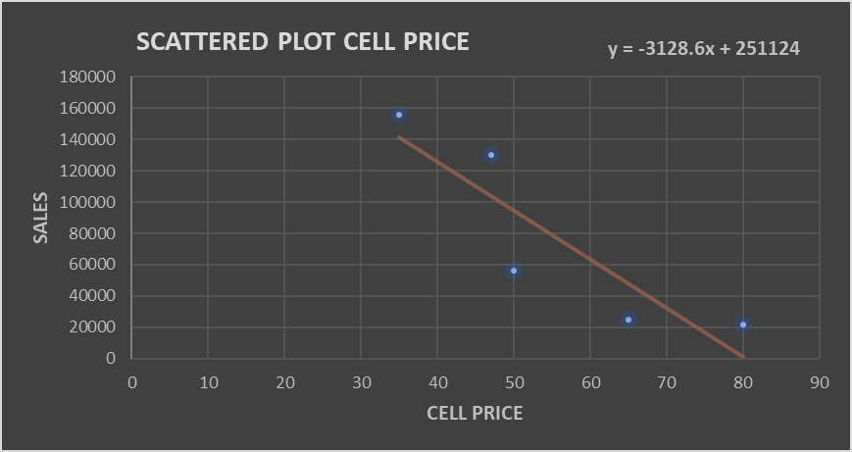

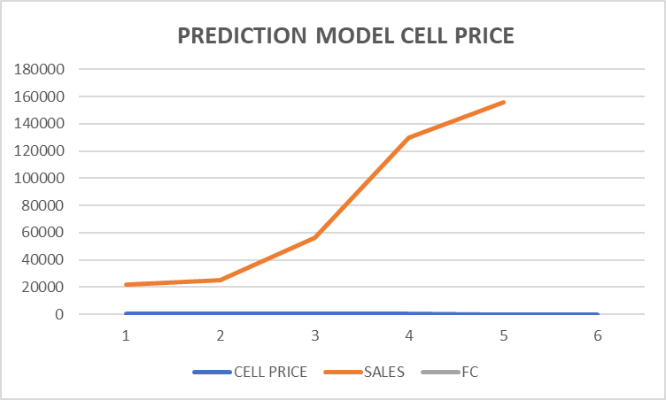

|  |  |  |  |  |
| --- | --- | --- | --- | --- |
| SLOPE (a) | -3128.59 |  | INTERCEPT (b) | 251123.6 |

Analysis- To draw a conclusion, we can observe that there is a negative relationship between the cell prices and the sales of EVs. With any reduction in these cell prices will lead to increase in the sales of EVs. Hence, from the prediction model we can see that, with similar pricing in 2021, there is a slight drop in sales. However, the sales drop due to cell prices in much lower than in battery pack prices. This is because, micro-fuel cells, once commercialized, hold the promise for providing more back up 'green power' at lower cost than its competing battery technologies.

THE TOTAL BATTERY COST FROM THE YEAR 2016 TO 2020 AND THE CORRESPONDING SALES OF ELECTRIC VEHICLES.



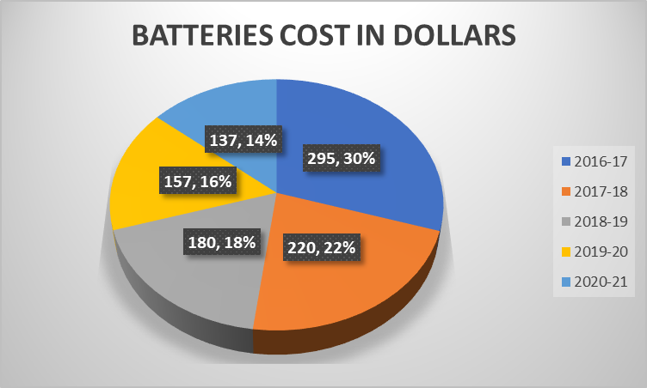

Carbon dioxide (CO₂) emissions from the burning of fossil fuels for energy and cement production. Land use change is not included

CO2 EMISSIONS PER CAPITA IN BILLION TONS

HERE, CO2- INDEPENDENT VARIABLE  
SALES- DEPENDENT VARIABLE



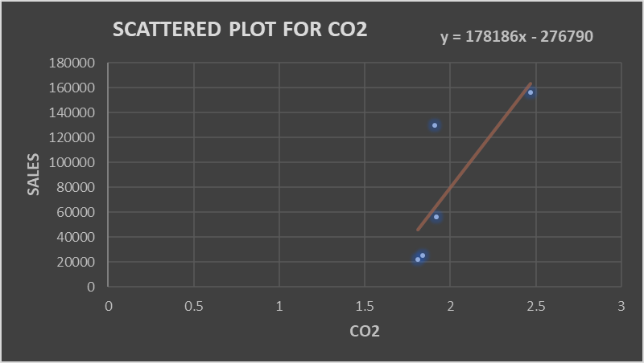

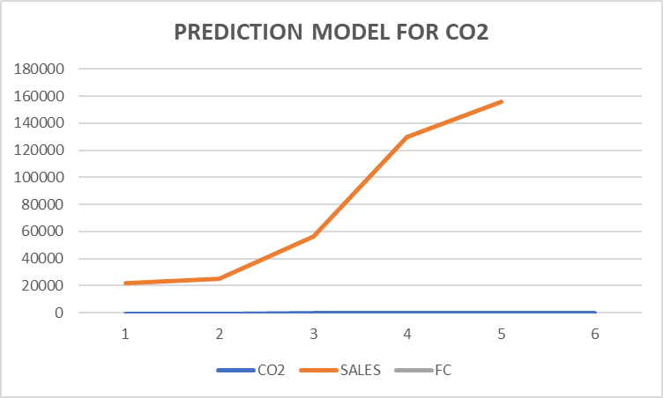

|  |  |  |  |  |
| --- | --- | --- | --- | --- |
| SLOPE(b) | 178186.1 |  | INTERCEPT(a) | -276790 |

Analysis- We can see from the above model that there is an positive relationship between the CO2 emission per capita and the sales of EVs. With the decreased numbers of the CO2 emission, the sales also drop. This is due to the facts that,

* The raw materials for building up EVs, like cobalt, lithium, ion is very difficult and rare to find. Any increase in sales of electric vehicles will lead to less sustainability. Additionally, lithium, cobalt and other such raw materials may cause more harm to the environment, like increase global warming and make the already scarce resources more limited.
* Lastly, there are very few EVs in proportion to the ICE vehicles (Internal Combustion Engine) so, any change in CO2 emission will not really be affected by the change in EV sales.

TOTAL SALES OF ELECTRIC VEHICLES FROM THE YEAR 2016-2020



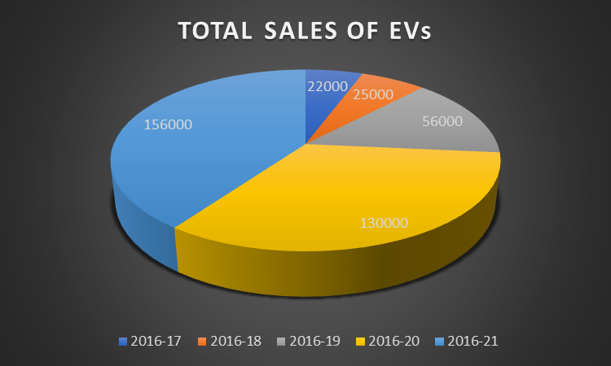

STACKED CHART FOR FOUR AND TWO-WHEELER ELECTRIC VEHICLES



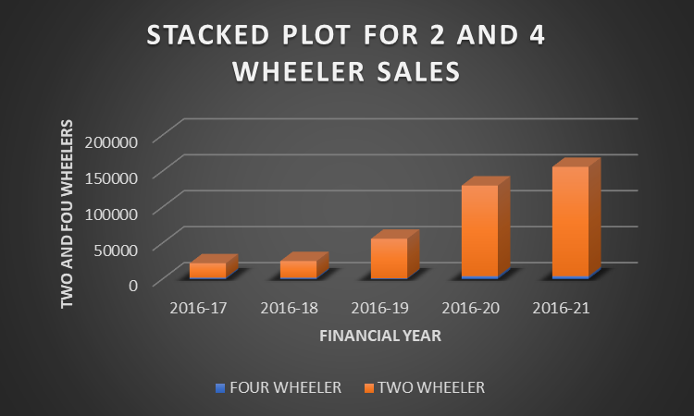

**CONCLUSION**

EVs are found to be energy efficient along with low-cost maintenance than fuel vehicles. During the purchase of a vehicle consumers usually focus on their initial investment and do not really appreciate the future gains. By capitalizing on this aspect certain measures can be taken which may result in the increased penetration of EV’s in the Indian market.

High cost is one of the reasons which divert the customers from purchasing EVs. To work upon this government has pushed for a wider EV adoption by offering subsidies to commercial vehicles. But electric cars still remain costlier by at least 30%, mainly due to imported batteries. The Centre’s Faster Adoption and Manufacturing of Hybrid and Electric Vehicles (FAME) scheme of 2015 rolled out subsidies for electric commercial vehicles.

Experts say the main challenges facing the EV industry are inadequate charging infrastructure and reliance on imported components and batteries. By 2023 all of this could chanage. Cost of battery imports are expected to come down. Over the last quarter, manufacturers have announced several new EV models that promise a higher range.

The CO2 emissions will only drop down if sustainability goal is kept in mind and the government schemes are properly directed and abided by. Our analysis shows that CO2 emissions and sales of EVs are positively related due to the fact that there are not enough sales and ICE car models are still outstripping the comparability with respect to the former. Thus, with gradual increase in sales, the CO2 may be expected to come down and hence, our prediction is based on low level sales of EVs only.

Lastly, we can observe that if there is a continuous rise in the fuel prices, it will only increase the demand for EVs due to the following reasons;

* the market will prefer a more economical method of investment thereby, leading them to switch to electric vehicles
* Electric vehicle is a step into the modern world and with less interest of consumers in ICE vehicles due to surge in fuel prices, it will only be a beneficial move to step into a safer and cheaper era of automobiles

All in all, although there are many shortcomings and challenges in EV sector for the Indian Economy, there is a lot of scope for advancement in this industry which can prove to be a big transitiong phase for India and its automobile industry.

**REFERENCES**

<https://www.researchgate.net/publication/353260957_Electric_Vehicles_in_India_A_Literature_Review>

<https://www.teriin.org/article/air-pollution-india-major-issues-and-challenges>

<https://journals.sagepub.com/doi/full/10.1177/0972262919875548>

<https://inc42.com/infocus/electric-vehicles-this-week/electric-vehicles-this-week-assessing-indias-2030-electric-mobility-goals-more/>

<https://www.ceew.in/sites/default/files/CEEW-India's-EV-Transition-Post-COVID-19-22Dec20.pdf>

<https://jmkresearch.com/electric-vehicles-published-reports/monthly-electric-vehicles-update/monthly-ev-update-july-2021/>

<https://www.iisd.org/articles/india-electric-vehicle-revolution>

NMEM (2018) National Automotive Board, FAME-India, [www.fame-india.gov.in/](http://www.fame-india.gov.in/)

ModelUnderFame.aspx (Last accessed 14 March, 2018).

PTI (2017) Delhi’s Diesel Consumption Reduced in 2016-17, Consumption of Petrol up Marginally, https://www.moneycontrol.com/news/business/wire-news/delhis-dieselconsumption-reduced-in-2016-17-consumption-of-petrol-up-marginally-2472185.html (Last accessed 20 February, 2018).

Sood, R. (2017) Delhi Government Declares Subsidies for Electric Vehicles, <http://www.ecardlr.com/car-news/delhi-government-declares-subsidies-for-electric-vehicles.aspx>

For electric vehicles being sold in India from 2015-2020

<https://dazeinfo.com/2020/05/28/total-electric-vehicle-sales-in-india-by-year-graphfarm/>

Petrol and diesel prices

<https://www.mycarhelpline.com/index.php?option=com_easyblog&view=entry&id=808&Itemid=91>

<https://www.firstpost.com/india/petrol-diesel-auto-fuel-price-in-your-city-today-delhi-mumbai-kolkata-chennai-bengaluru-hyderabad-august-21-2021-9901881.html>

[https://www.firstpost.com](https://www.firstpost.com %0d)

<https://www.industryweek.com/technology-and-iiot/energy/article/22017905/electric-cars-soon-will-cost-less-than-gasoline-autos-research-shows>

Prices of Batteries for EVs

<https://auto.economictimes.indiatimes.com/news/auto-components/evs-to-close-in-on-ice-vehicles-in-few-years-as-battery-costs-expected-to-plummet-to-100/kwh-by-2023/79764942>

[https://www.renewableenergyworld.com/storage/annual-survey-finds-battery-prices-dropped-13-in-2020/#gref](https://www.renewableenergyworld.com/storage/annual-survey-finds-battery-prices-dropped-13-in-2020/" \l "gref)

CO2 Emissions

<https://www.carbonbrief.org/analysis-indias-co2-emissions-fall-for-first-time-in-four-decades-amid-coronavirus>

<https://ourworldindata.org/co2/country/india>

<https://jmkresearch.com/electric-vehicles-published-reports/monthly-electric-vehicles-update/monthly-ev-update-july-2021/>

Regression Model theory

<https://youtu.be/8iqzFQ_nZI8>